[www.colwickhallhotel.com](http://www.colwickhallhotel.com) @colwickhall 0115 950 0566

Here is the Map which shows the variety of different walk trails which takes you around the Lake and also leads to Colwick Country Park

* Kingfisher
* Mallard
* Owl

Just outside on our grounds the steps leads to the pathways for you to explore

Our reception team are happy to show you the way to get you started on your adventure

Pre-order your Afternoon Tea and take along a picnic for your travels

Can you spot the Colwick Hall Ice House in the woods?

Ice Houses were built below ground in the 17th century designed for ice to be collected from the Lake and if properly insulated lasted all year round for the large estates

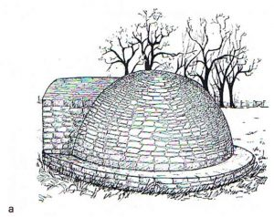

For any food & drink orders either to your bedroom or a table on the grounds just shine your mobile camera to this QR code & enjoy your well deserved treat.

***Celebrating special occasions***

Now 2000’s

2003

Grounds were finally restored

2004

Opening as a Wedding & Function venue

2005

The luxurious bedrooms you stay in today were created using the original fabric and elaborate details

2013

We proudly opened our Byron’s Brasserie

2017

Our Wizarding themed Afternoon Tea won critical acclaim and was featured in over 60 publications. Attracting over 10,000 visitors from all over the UK & Ireland

Coming soon from 2023- 2026

Our exciting phase of development within the grounds will feature three new buildings. Starting in 2023, Heywood House and Lovelace Court will accommodate luxurious bedrooms with balconies. These will have accessible rooms and also be pet friendly. Set behind a Victorian garden wall with intricate design and landscaped paths together with espalier vines to link together. Wentworth Orangery will then culminate with large function spaces attracting floor to ceiling light and state of the art AV coupled with the lake vista and a new sensory garden.

***800 years of rich history***

1827

Jack Musters inherited the hall. The Musters had many relations to the Byron’s including Mary Ann Chaworth who was the first woman the famous poet Lord Byron fell in love with

1831

Riots during Second Reform Bill. During this disturbance the main gates were thrown in the lake where it lay rusting and forgotten for many years to then be recovered accidently and is now preserved in Nottingham Castle. Mary Chaworth escaped, hiding in the shrubbery, but received a shock & chill and sadly passed away at Wiverton Hall a few months later

1890’s

Col Horatio Davies who we know as the owner of Pimm’s acquired Colwick Hall

1910

As an ideal resort, arriving via steam ship, taking tea on the lawn and staying in bed chambers. Enjoying mirth & laughter whilst being entertained by Pierrots

***A Warm Welcome to Colwick Hall Hotel***

***We hope you enjoy your stay with us.***

Colwick Hall stands on a site which has been occupied ever since Saxon days and the names of the owners are legion

Starting at 1086

Colwick Hall was first recorded in the Domesday Book. Held by the service of twelve barbed arrows which you can see today on our main gates and grand staircase

Owned by Sir Reginald DeColwyck who lived to be a Centenarian

1362

On the death of William DeColwyck, the estate was passed by marriage of his daughter Joan to Sir Richard Byron

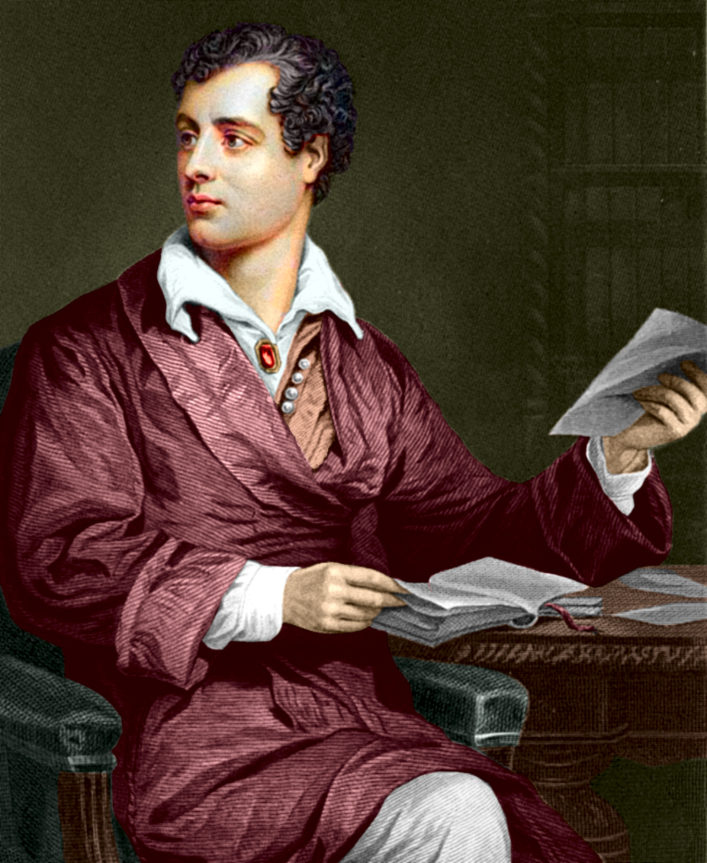 *The portrait of Lord Byron, Poet*

1776

The house was remodelled as you see it now by John Carr of York, in a Palladian style with ionic pillars, for Sir John Musters. The current Flemish redbrick face with initials J.M 1776 on lead downpipe hops

